**Definition: Use Text Properties, font Properties, Google Fonts, and custom fonts in Figma.**

**Solution:**

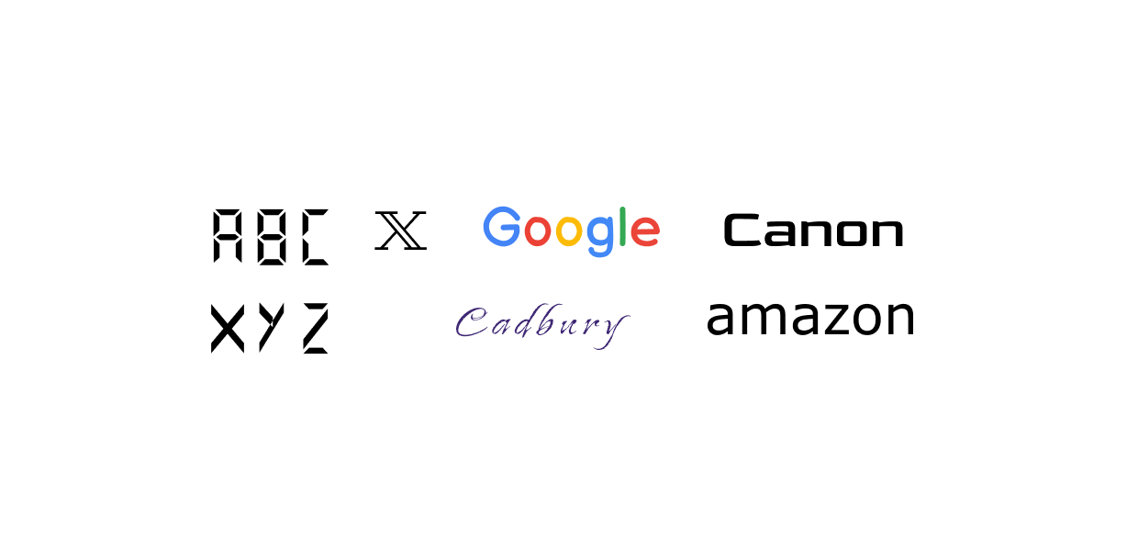

**Steps:**

* First Open Figma in browser mode.
* Then create the new document **File à New Figma Design**.
* Set the background page color=**”#1E1E1E”.**
* Now add one frame using the Frame tool of width=”**300 px”** and height=”**150 px”** on your canvas.
* The frame inside the write a “**ABCXYZ**”using the text tool to center and text of color=”**#000000**” text size=**”14 px”** and font name=**”Digital Numbers”**.
* Write “**Google”** inside the frame using the text tool of color=”**#4384F7**” ,”**#EB4235**” ,**”#FDBB05**”, ”**#4289F7**”, ”**#34A852**” and **“#EB4438”** text size=**”15 px”** and font name=**” Balsamiq Sans”**.
* Write “**Canon”** inside the frame using the text tool of color=”**#000000**” text size=**”15 px”** and font name=**”Goldman”**.
* Write “**Cadbury”** inside the frame using the text tool of color=”**#3E2774**” text size=**”15 px”** and font name=**”Island Moments”.**
* Write “**Amazon”** inside the frame using the text tool of color=”**#000000**” text size=**”15 px”** and font name=**”MS reference sans serif”.**
* Write “X**”** inside the frame using the text tool of color=”**#000000**” text size=**”15 px”** and font name=**”Geostar”.**
* Now, Go to the **Export** button in the property panel. And **Export** it with .**JPG/.PNG** format.